**ASME- HKS ACTIVITY REPORT**

**ACTIVITY Technical Visit to Zhuhai Fabrication Yard of COOEC-Fluor Heavy Industries Co**

**DATE 25 November 2017**

**VENUE Zhuhai Fabrication Yard of COOEC-Fluor Heavy Industries Co**

**PREPARED BY Kent Choy and Tony Wong**

**SEQUENCE OF ACTIVITY**

* The technical visit was initiated by ASME Hong Kong Section in June 2017
* Work group was formed in August 2017 to discuss logistic arrangement, promotion, and visit itinerary etc.
* Visit date of 25 November 2017 was confirmed in September 2017
* Invitation to HKIE-MMNC and IMechE-HKB was sent in October 2017 to co-organize the activity with financial commitment from each Society
* Promotion and online enrollment was commenced in Early October 2017

**SUMMARY**

* A total of 20 participants from members of the three societies ASME-HK, HKIE-MMNC and IMechE-HKB attended. 15 enrollments were rejected for better tour size control. Please refer to the attached enrolment list for details.
* The host generously provided shuttle bus to and from the fabrication yard and also lunch at the fabrication yard.
* A group of 5-6 engineers and safety manager welcomed us at a conference room with video introduction of the company and the fabrication yard, and a comprehensive safety briefing (full set of safety gears were provided to all participants). It was followed by touring around the fabrication yard, to appreciate the workflow of module fabrication, including material cutting and welding workshop, blasting and painting workshop and assembling skidway.

*[Password: 1324]*

FINANCIAL OUTCOME

* Registration Fees of $4,000 was collected from the participants requested for paying $200 each. Price of outbound and return ferry tickets amounted to $ 6,740. Photo Frame for Certificate of Appreciation costed $42.7. $ 927.6 is required to be contributed by each Society to break even. Please refer to the attached Expense Report for details.



**RECOMMENDATIONS**

* Some introduction of the design or installation of modules will benefit the participants more. For example, it was difficult for a participant who does not have offshore background to visualize how a module is loaded and transported to the destination. It could be achieved by better communication of our expectation with the host.

**APPENDIX - PHOTOS**

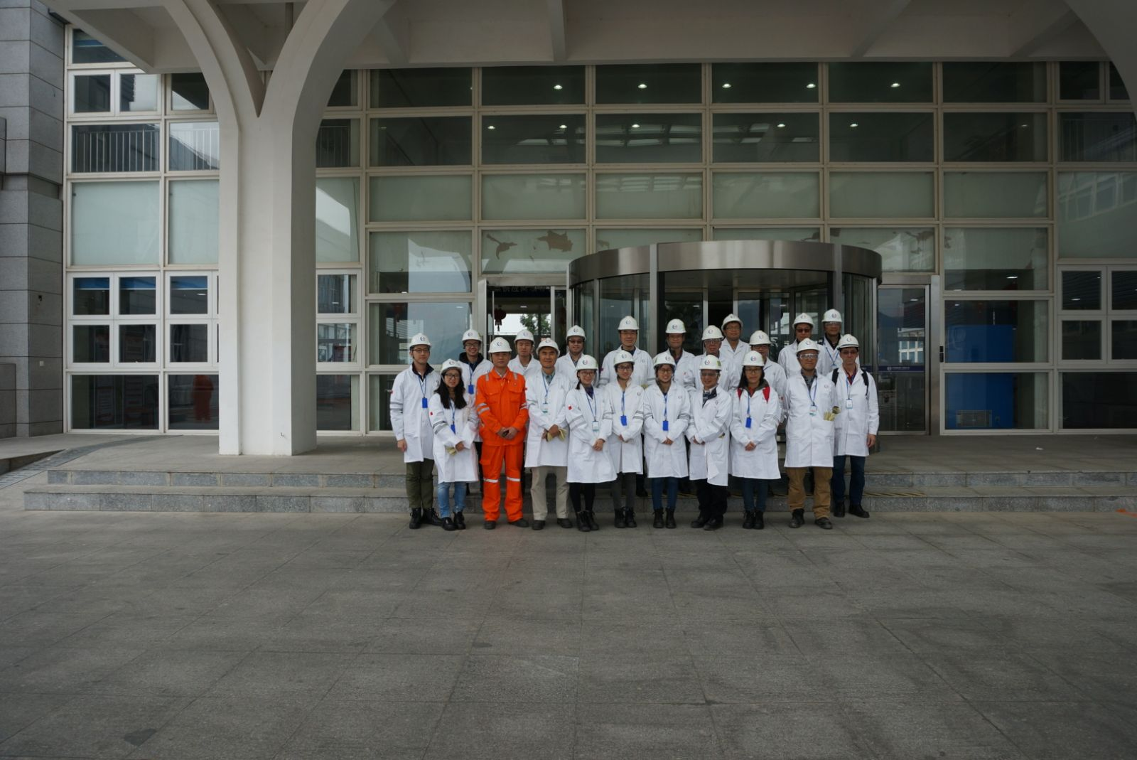

Photo 1: Group photo

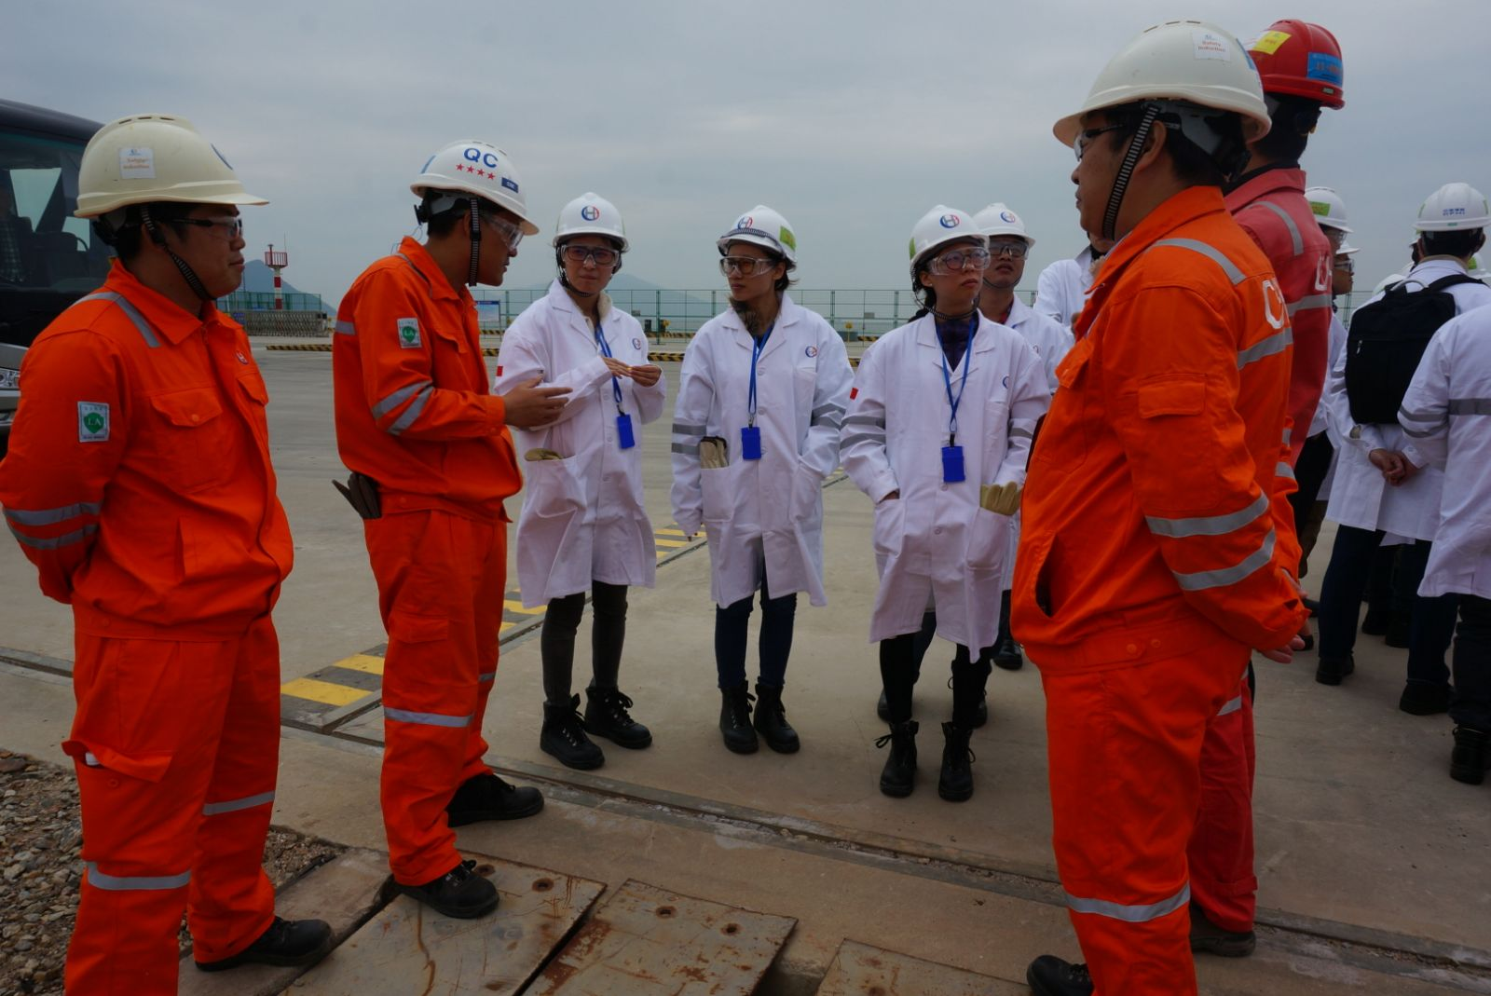

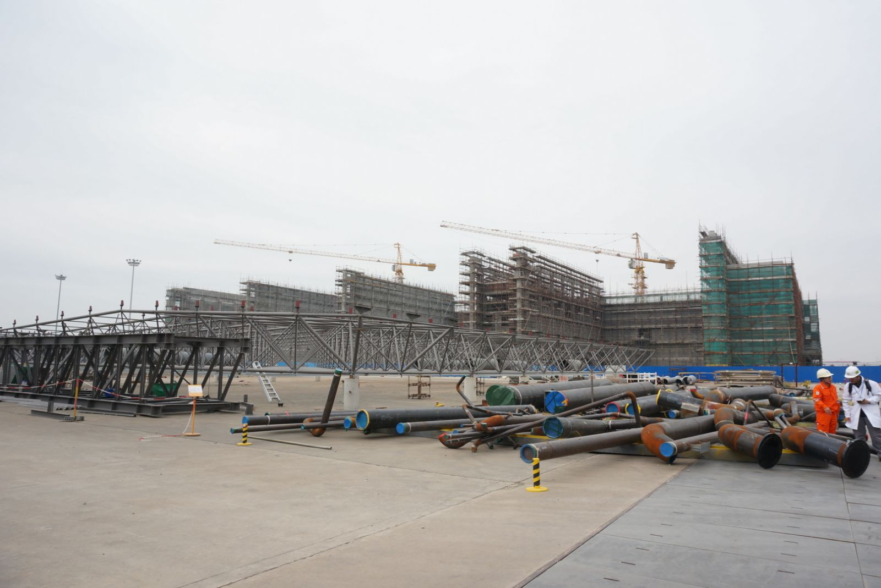

Photo 2: Site Tour

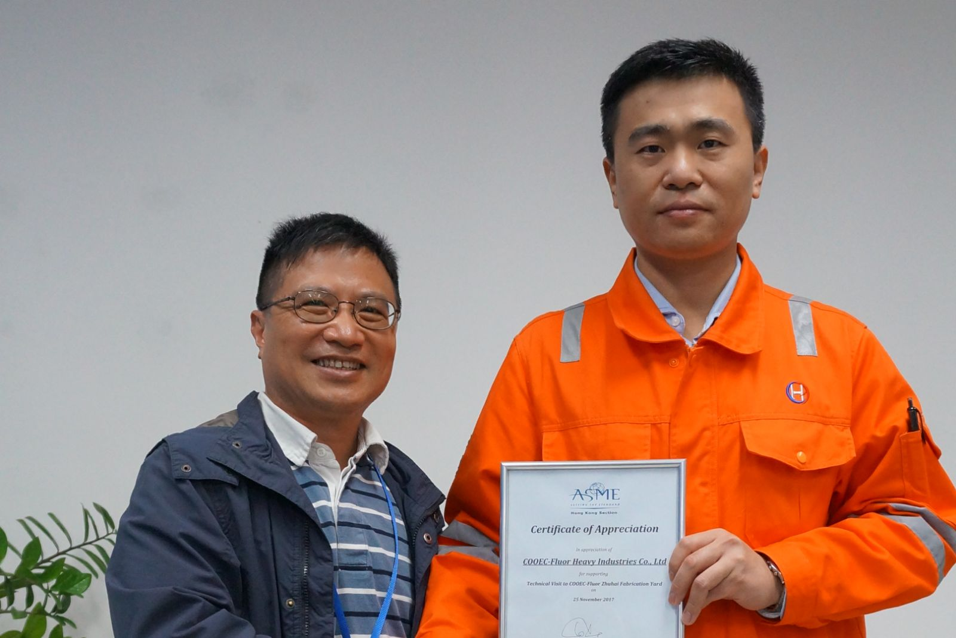

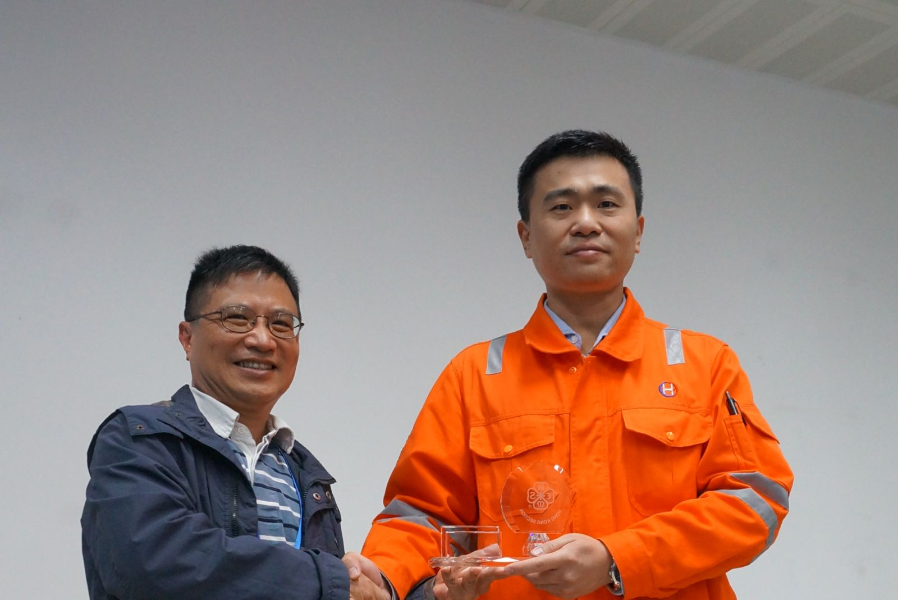

Photo 3: Souvenir and Certification Presentation